ILLNESS AND INFECTION CONTROL POLICY

Statement of Intent:

It is our aim to minimise the spread of infectious diseases (including Covid-19) for staff and students through the implementation of infection controls which reduce the transmission and spread of germs. We aim to promote and maintain the health of pupils and staff through the control of infectious illnesses.

Policy and Procedure:

It is the policy of the School to:

- Protect students attending from the transmission of any kind of infection.
- Protect persons working in the School from the transmission of any kind of infection.
- To use signage such as hand washing signs and nose blowing signs which are beneficial to both staff and students.

Breakout of Illness/Diseases

In the event of an outbreak of any infectious disease, all parents will be informed by email. Infected students will be moved to the sick bay/isolation area and parents will be asked to make arrangements to transfer the students home.

Any students or staff with symptoms of an infectious illness will not be permitted to attend the School until they are no longer infectious. The management of the School will ensure that all areas of the premises are thoroughly disinfected, following confirmation of an outbreak.

The school have access to a local GP who may be asked to attend to the student and provide medical advice

Roche Nagle Medical Practice,
Kickham Street Medical Centre,
Kickham Street,
Carrick-on-suir,
Co. Tipperary.

Ph: 051-640565

Reporting/Recording of illness:

A contingency plan is in place should an outbreak of an infectious disease occur. All staff roles and responsibilities regarding reporting procedures are clearly defined. Staff will report any infectious illness to the Principal. The Principal will report an outbreak of any notifiable infectious disease to the Public Health Department. The Principal will record all details of the illness reported to them by staff. These details will include the name, symptoms, dates, and duration of the illness.

Notifiable Diseases

Diagnosis of a student attending the school, an employee, unpaid worker/volunteer, contractor, or other person working in the school as suffering from an infectious disease within the meaning of the Infectious Disease Regulations 1981(SI No 390 of 1981) and amendments will trigger an action plan.

When to contact the local Department of Public Health

- If there is a concern about a communicable disease or infection, or advice is needed on controlling them.
- If there is a concern that the number of students who have developed similar symptoms is higher than normal.
- If there is an outbreak of infectious disease in the school.
- To check whether to exclude a student or member of staff before sending emails to parents/guardians about an infectious disease.

Infectious illness can cause significant ill health among young students and can be transmitted by direct or indirect contact including:

- Contact with infected people or animals.
- By infecting oneself with the body’s own germs.
- By hand to mouth transmission.
- By the air / by insects, pests, animals.
- Indirect transmission: door handles, toilets, floors, table tops etc.
- By direct – person to person.

Reporting/Recording of Illness:

- Staff must report any infectious illness, or similar, to the Principal.
- The Principal (or nominated person) will record the outbreak on an Incident Form and report an outbreak to Environmental Health Officer and the Public Health Department.
- The Principal will record all details of illness reported to them by staff or reported by parents/guardians of a student attending the School. These details will include the name, symptoms, dates, and duration of illness.

Exclusion from the School:

- We advise parents and staff that sick students or adults should not attend if they have any infectious condition
- Students will be excluded from the school based on the time frames outlined in the exclusion table (APPENDIX I)
- A doctor’s certificate may be required for certain conditions to ensure they are no longer contagious before students or staff return to the School.

To ensure the safety and health of all our students and staff those who have any of the following conditions will be excluded from the School:

- An oral temperature over 38 degrees which cannot be reduced.
- A deep, hacking cough.
- Severe congestion.
- Difficulty breathing or untreated wheezing.
- A pupil that complains of a stiff neck and headache with one or more of the above symptoms.
- Any symptoms of Covid-19.

Isolated from the group and GP attention sought:

- Acute symptoms of food poisoning/gastro-enteritis.
- An unexplained rash (see exclusion list also).
- Vomiting (48 hours from last episode).
- Diarrhoea (48 hours from last episode).
- Lice or nits – [see Head Lice Policy in Infection Control Policy]
- An infectious /contagious condition.

Immunisations and Safe Management of unvaccinated pupils
- We encourage parents/guardians to immunise their children.
- We ask parents and guardians to submit immunisations details at the time of enrolment
- Immunisation records must be kept up to date (Appendix 2: Immunisations). This should contain dates of immunisations. Where dates are not available all attempts to get these should be recorded.

Students Who Are Not Immunised: Safe Management
- Where students attending the School are not immunised the School requires the parents/guardians to complete a disclaimer in the form set out in Appendix 3 which also confirms that pupils may be required to be excluded in the event of a breakout of disease

Parents of Students and Staff not immunised will be promptly informed if there is an outbreak of an infectious disease (even if they don’t have the condition) and may need to be excluded from the school, until deemed safe to return. Medical advice should be sought.

Vulnerable students

Some medical conditions make students vulnerable to infections that would rarely be serious in most pupils, these include those being treated for leukaemia or other cancers, on high doses of steroids and with conditions that seriously reduce immunity. These students are particularly vulnerable to chickenpox, measles and parvovirus B19 and, if exposed to either of these, the parent/carer should be informed promptly and further medical advice sought.

Hand Hygiene:

Hand washing guidelines are displayed at each sink.
We will follow the following protocol in terms of hand washing:

We will wash our hands frequently with soap and warm water or use an alcohol-based hand rub (preferably minimum 60% alcohol) if hands are not visibly dirty for 40-60 seconds and in line with the WHO and HSE recommendations. Water will be controlled to 43 degrees C.

- The school will promote good hand hygiene techniques in line with HSE and WHO guidelines, and support students to do the same through modelling, signage, activities, supervision, and games.
- We will ensure an adequate supply of liquid soap, hand gel or rub and disposable or paper towels available throughout the premises including the arrival and outdoor areas. All hand gels and rubs must be kept out of student ’s reach.
- All hand gels in use for staff, parents or visitors to the School are alcohol based.
- We will use liquid soap and warm running water for hand washing and only use hand gels or rubs where running water is not available.
- Hand gel or rub must be applied vigorously over all hand surfaces, for 40-60 seconds, and are only effective if hands are not visibly dirty.
- If hands are physically dirty, then they need to be washed with liquid soap and warm water and students and staff will have to go to the nearest sink or bathroom.
- Staff and students will be encouraged to avoid touching their eyes, their mouth or nose with their hands.

a. How to wash your hands with soap and water (HSE)

- Wet your hands with warm water and apply soap.
- Rub your hands together until the soap forms a lather.
- Rub the top of your hands, between your fingers and under your fingernails.
- Do this for about 20 seconds.
- Rinse your hands under running water.
- Dry your hands with a clean towel or paper towel.

b. Students should wash their hands and be supervised doing so

- When they arrive at the School and before they go home
- Before eating and drinking
- After being outside
- After sneezing or coughing into their hands
- Whenever hands are visibly dirty

c. Staff should wash their hands

- When they arrive at the School and before they go home
- After coughing and sneezing
- Before handling food
- Between handling raw and cooked food
- Before and after eating their own food – breaks/lunches
- Before and after giving or applying medication or ointment to a pupil
- If staff have physical contact with a pupil
- After contact with bodily fluids
- After cleaning tasks
- After removing gloves
- After handling rubbish
- Whenever hands are visibly dirty
- If in contact with someone who is displaying any COVID-19 symptoms
- Before and after being on public transport [if using it]
- Before and after being in a crowd
- Before having a cigarette or vaping

Hand-drying

Disposable single use papers towels will be used for hand-drying

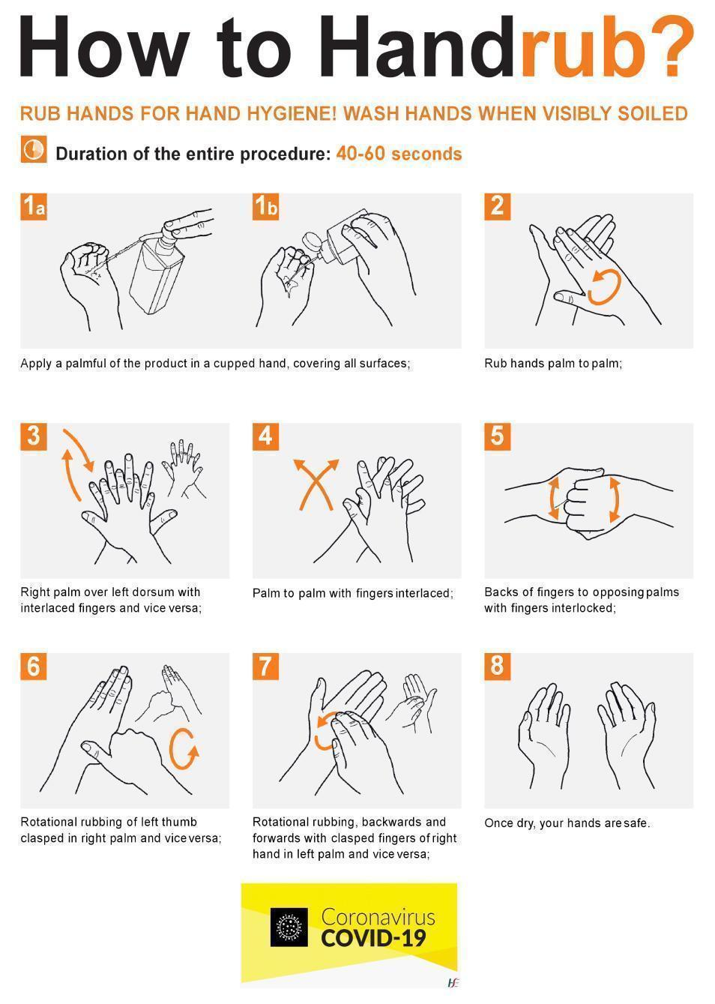

Alcohol-based Hand Rub/Gels:

When soap and running water are not readily available, for example on a field trip or excursion, an alcohol-based hand rub/gel may be used (the alcohol content should be at least 60%). The alcohol-based hand rub must be applied vigorously over all hand surfaces. Alcohol based hand rubs are only effective if hands are not visibly dirty, if hands are visibly dirty then liquid soap and water should be used. It is safe to let pupils use alcohol-based hand rubs/gels, but it is important to let pupils know that it should not be swallowed. Supervision is vital. It is also important to store it safely so students cannot get access to it without an adult.

The alcohol content of the product generally evaporates in 15 seconds so after the alcohol evaporates it is safe for students to touch their mouth or eyes. Water is not required when using an alcohol rub/gel.

Alcohol based hand rubs/gels are not a substitute for hand washing with soap and running water.

Respiratory Hygiene (Coughing and Sneezing):

Everyone should cover their mouth and nose when coughing and sneezing to prevent germs spreading. In addition:

- A plentiful supply of disposable paper tissues should be readily available for nose wiping.
- Foot operated pedal bins that are lined with a plastic bag should be provided for disposal of used/soiled tissues.
- Cloth handkerchiefs should not be used.
- Students and staff should be reminded to cover their mouth when they cough or sneeze and to wash their hand afterwards. They should cough into their elbow.
- Everyone (staff and students) should put their used tissues in a bin and wash their hands after contact with respiratory secretions.
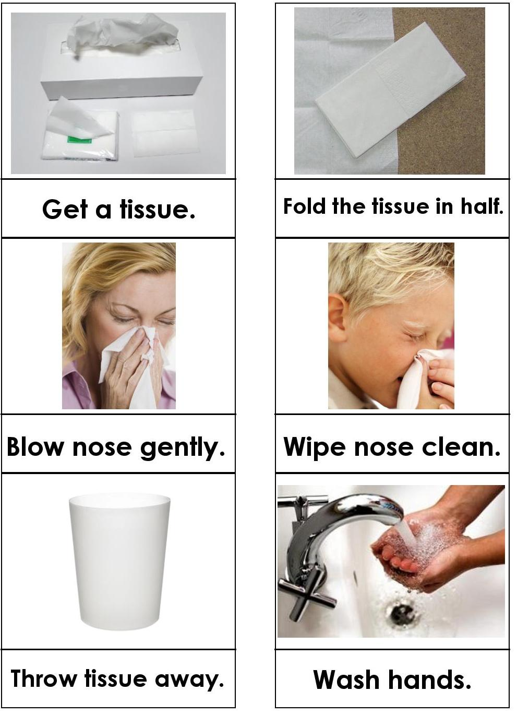

Nose Blowing Procedure:

Tissues are available always and
Students will be reminded of the following
etiquette for nose blowing.

1. Get a tissue
2. Fold it in half
3. Blow nose gently
4. Wipe nose clean
5. Throw tissue away in bin
6. Wash hands

Cleanliness and Hygiene:
To prevent cross-contamination:

- Aprons and paper-towels are in dispensers and not openly left on shelves
- Gloves and aprons are used to clean up bodily fluids
- Detergents and disinfectants are used correctly according to manufacturer’s instructions
- The premises will be maintained in a clean, hygienic state throughout the day and a cleaning record is kept.
- Staff are responsible for the materials and equipment used and ensure they are clean, hygienic, and safe always.
- Pupils will be encouraged to care for their environment.
- Cleaning routines and procedures are in place and are closely monitored and recorded.
- Disposable cloths will be used for all cleaning purposes and discarded regularly.

Spillages of Body Fluids: (e.g., urine, faeces, or vomit)
To prevent cross-contamination:

- Put on disposable plastic apron and gloves.
- Use absorbent disposable paper towels or kitchen towel roll to soak up the spillage.
- Clean the area using warm water and a general-purpose neutral detergent, use a disposable cloth.
- Apply a disinfectant to the affected surface.
- Dry the surface thoroughly using disposable paper towels.
- Dispose of soiled/sodden paper towels, gloves, apron, and cloths in a manner that prevents any other person coming in contact with these items e.g., bag separately prior to disposal into a general domestic waste bag.
- Wash and dry hands thoroughly.
- Change clothing that is soiled immediately.

Blood Spillages:
To prevent cross-contamination:

- Put on disposable plastic apron and gloves.
- Use absorbent disposable paper towels or kitchen towel roll to soak up the spillage.
- Apply a disinfectant to the affected surface. It should be left in contact with the surface for at least two minutes (check the manufacturer’s instructions).
- Wash the area thoroughly with warm water and a general-purpose neutral detergent and dry using disposable paper towels.
- Dispose of soiled/sodden paper towels, gloves, apron, and cloth in a manner that prevents any other person coming in contact with these items e.g., bag separately prior to disposal into a general domestic waste bag.
- Wash and dry hands thoroughly.
- Change clothing that is soiled immediately.

Dealing with Cuts and Nose Bleeds:
To prevent cross-contamination:

When dealing with cuts and nose bleeds, staff should follow the School’s first aid procedure. They should:

- Put on disposable gloves and apron.
- Stop the bleeding by applying pressure to the wound with a dry clean absorbent dressing.
- Place a clean dressing on the wound and refer the pupil for medical treatment if needed, e.g., stitches required or bleeding that cannot be controlled.
- Once bleeding has stopped, dispose of the gloves and apron safely immediately in a manner that prevents another person coming in contact with the blood, i.e., bag separately prior to disposing into general domestic waste bag.
- Wash and dry hands.

Students who are known to be HIV positive or Hepatitis B positive should not be treated any differently from those who are not known to be positive. Intact skin provides a good barrier to infection and staff should always wear waterproof dressings on any fresh cuts or abrasions on their hands. Staff should always wash their hands after dealing with other people’s blood even if they have worn gloves or they cannot see any blood on their hands.

Gloves:

Wear disposable gloves when dealing with blood, body fluids, broken/grazed skin, and mucous membranes (e.g., eyes, nose, mouth). This includes activities such as:

- Cleaning up blood – e.g., after a fall or a nosebleed.
- General cleaning.
- Handling waste.

Gloves should be single use and well fitting.

Types of Gloves:

- Disposable non-powdered latex or nitrile gloves are recommended. Synthetic vinyl gloves may also be used but users should be aware that gloves made of natural rubber latex or nitrile have better barrier properties and are more suitable for dealing with spillages of blood or body fluids.
- Gloves should conform with the European Community Standard (CE marked).
- Polythene gloves are not recommended as these gloves tear easily and do not have good barrier properties.
- Latex free gloves should be provided for staff or students who have latex allergy.

How to Remove Gloves:

- Peel the first glove back from the wrist.
- Turn the glove inside out as it is being removed.
- Remove the glove completely and hold in the opposite hand.
- Remove the second glove by placing a finger inside the glove and peeling it back. Pull the glove off over the first glove.
- The outside surface of the glove should not be touched.
- Hand washing should be performed following glove removal.
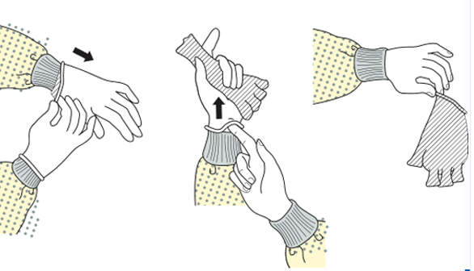
Source: US Centers for Disease Control and Prevention

Aprons:

Wear a disposable apron if there is a risk of blood or body fluids splashing onto skin or clothing, for example during activities such as cleaning up spillages of body fluids (e.g., blood, vomit, urine) or dealing with nose bleeds. Change aprons after caring for individual pupils. Wash hands after removing the apron. Aprons should be disposable, single use and water repellent. The apron should cover the front of the body from below the neckline to the knees. Cloth aprons or gowns are not recommended. Remove the apron by breaking the neck ties first, then break the ties at the back and roll up the apron without touching the outer (contaminated) surface. If gloves and an apron are worn remove the gloves first followed by hand washing.

The Monkeypox Virus

Monkeypox is a rare infection. It's mainly spread by wild animals in parts of west or central Africa. The risk of catching it in Ireland is very low. Currently, as of 26th May 2022, there are no cases of Monkeypox.

How You Get Monkeypox:
You can get Monkeypox from infected wild animals in parts of west and central Africa. It's thought to be spread by rodents, such as rats, mice and squirrels. You can catch Monkeypox from an infected animal if you're bitten by it, or you touch its blood, body fluids, spots, blisters or scabs.

It may also be possible to catch Monkeypox by:

- Eating meat from an infected animal that has not been cooked thoroughly.
- Touching other products from infected animals, such as animal skin or fur.

It's very uncommon to get Monkeypox from someone else. It does not spread easily between people. It takes close physical contact to spread between people. The biggest risk of spread between people is through sexual contact or close contact with family members.

It can also be spread through:

- Touching clothing, bedding or towels used by someone with the Monkeypox rash.
- Touching Monkeypox skin blisters or scabs.
- The coughs or sneezes of a person with the Monkeypox rash.

Monkeypox in Ireland:
If you have been in close contact with someone who has Monkeypox, you'll be contacted by health professionals. If you have not been contacted, and you have not travelled to west or central Africa, it's extremely unlikely you have Monkeypox.

Symptoms of Monkeypox:
It usually takes between 5 and 21 days for the first symptoms to appear. The symptoms usually clear up in 2 to 4 weeks. The first symptoms of Monkeypox include:

- High temperature (38 degrees Celsius or higher)
- Headache
- Muscle aches
- Backache
- Swollen glands
- Shivering (chills)
- Exhaustion

A rash usually appears 1 to 5 days after the first symptoms. The rash often begins on the face, then spreads to other parts of the body. If Monkeypox has been spread through sexual contact, the rash can appear around the genitals. The rash is sometimes confused with chickenpox. It starts as raised spots, which turn into small blisters filled with fluid. These blisters eventually form scabs which later fall off. Very occasionally people with a very weak immune system.

Urgent Advice - contact a GP if you have:
- Symptoms of Monkeypox and have recently returned from west or central Africa.
- Been in contact with someone who has Monkeypox.
- Unusual rashes or spots on your body, especially genitals (contact local STI clinic).

Things You Can Do to Avoid Getting Monkeypox:
Monkeypox is rare. But there are things you can do to reduce your risk of getting it while travelling in west and central Africa.
Do:
- Wash your hands with soap & water regularly or use alcohol-based hand sanitiser.
- Only eat meat that has been cooked thoroughly.
Don’t:
- Do not go near wild or stray animals, including dead animals.
- Do not go near any animals that appear unwell.
- Do not eat or touch meat from wild animals (bush meat).
- Do not share bedding/towels people who are unwell and may have Monkeypox.
- Do not have close contact with people who are unwell and may have Monkeypox.

Treatment for Monkeypox:

Treatment for Monkeypox aims to relieve symptoms. The illness is usually mild. Most people recover in 2 to 4 weeks.

You'll usually need to stay in hospital, normally in a single-person room. This is so the infection does not spread to other people and your symptoms can be treated. Once discharged from hospital, your employer may request a ‘fit-to-return’ certificate from your GP to state that you are no longer infectious.
Source: https://www2.hse.ie/conditions/monkeypox/

What does Monkeypox rash look like?

The rash is more common on the hands, feet, arms, and legs. It also tends to follow a particular pattern: flat, round lesions (macules) growing into slightly raised bumps (papules), then into bumps filled with clear fluid (vesicles).

Images of individual Monkeypox lesions:
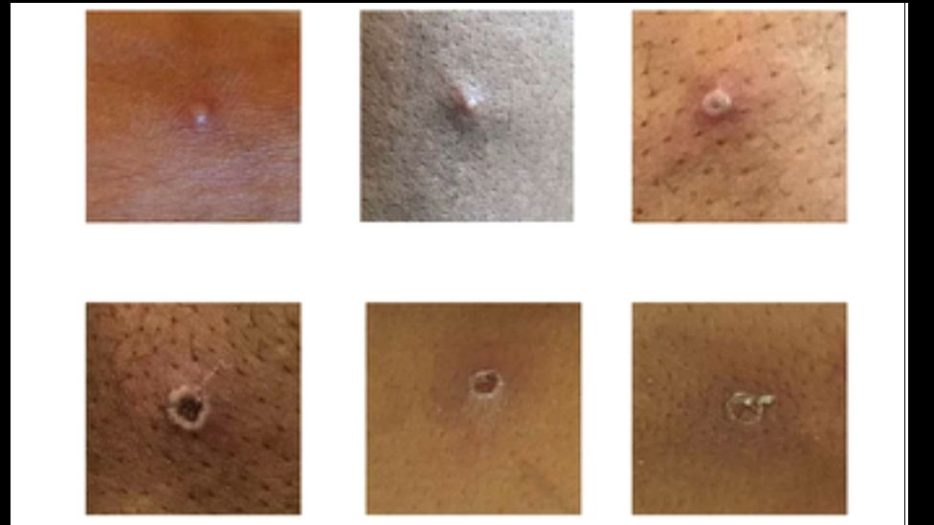
Source: https://www.insider.com/monkeypox-rash-pictures-when-to-get-checked-2022-5

Covid-19 Policy and Response Plan:
Links Relevant to Covid-19:

As the information regarding isolation and restriction changes regularly consult the HSE website for current details.

COVID-19 is a new illness caused by a new coronavirus (SARS-CoV-2) which is spread mainly through tiny droplets scattered from the mouth or nose of a person with the infection. The droplets can be scattered when the infected person coughs, sneezes, talks, laughs, shouts, or sings. To infect you, it must be droplets from an infected person's nose or mouth into your eyes, nose, or mouth.

Anyone can get this illness but to date the evidence is that older people and those in at risk categories are most seriously affected.

The most common symptoms are

- Cough - this can be any kind of cough, usually dry, but not always, and usually persistent
- Fever - high temperature equal to or greater than 38 degrees Celsius
- Shortness of Breath
- Breathing Difficulties
- Loss of sense of smell
- Loss of sense of taste or a distortion of sense of taste

It can take up to 14 days for symptoms to appear. Some cases are asymptomatic, meaning there are no symptoms, however if tested the person would likely test positive for COVID-19.

Symptoms in students

Parents of students with the following symptoms should be advised to keep their children at home and seek the advice of their GP.

- Fever equal to or greater than 38 degrees Celsius
- A new cough, shortness of breath or deterioration in existing respiratory condition
- Diarrhoea, Vomiting, abdominal pain (unlikely to be the sole symptoms, but may require testing if they occur with a fever)
- Loss of sense of smell, loss of sense of taste or a distortion of sense of taste (where pupils can express or describe these symptoms)

Students with above symptoms are likely to be referred for COVID-19 testing and will be advised to stay at home and self-isolate until test results are known.

If a student is sent for a test, the whole household must restrict movements until the results of the test are known. Parents must follow the isolation, restriction, and testing guidelines relevant at the time of the incident by consulting the HSE website and the pupil cannot return until they are COVID free, and it is safe to do so. If a parent is unsure of the guidelines they are encouraged to talk to management for assistance.

Self-isolation

Self-isolation means staying indoors and completely avoiding contact with other people. This includes other people in your own household, as much as possible. It applies to people with proven or suspected COVID-19.

Restricting movement

Restricting movement means avoiding contact with other people and social situations as much as possible. It applies to people who are without symptoms but considered at higher risk of developing COVID-19 because they were exposed to a particular risk e.g., are a close contact, travelled to a non-green list country

The HPSC has published a quick guide to self-isolation and restricted movement which is very helpful in understanding what the difference is between self-isolation and restricted movement and the conditions under which these processes are necessary. This guide changes regularly and will be consulted when an episode arises in the setting.

https://www2.hse.ie/conditions/covid19/preventing-the-spread/child-returning-to-school-or-childcare/

How it is transmitted or spread

The virus is transmitted through direct contact with respiratory droplets of an infected person (generated through coughing, sneezing, shouting, singing).

It can take up to 14 days for symptoms to appear. The evidence indicates that people with symptoms appear to be the most infectious in the early days after their symptoms appear. In some cases, there may be pre-symptomatic transmission in the day or two before symptoms appear. Some cases are asymptomatic, meaning there are no symptoms, however the individual is COVID-19 positive and could transmit the illness.

Individuals can also be infected from touching surfaces contaminated with the virus and then touching their face (e.g., eyes, nose, mouth). The COVID-19 virus may survive on surfaces for several hours e.g., plastic, or stainless steel up to 72 hours and cardboard less than 24 hours.

Covid-19 Vaccination

Vaccination against COVID-19 is being rolled out in Ireland and our School encourages participation in the programme.

Ventilation

The School will be kept well ventilated

Risk management and COVID-19

In managing the risks associated with COVID-19 in the school, the risk management process outlined in the school’s Risk Management Policy will be used. The risk management approach will focus on identifying the hazards, the level of risk and the controls to address the risks identified. Risk assessment forms will capture the risks identified, the level of risk and the control measures that have been put in place. An incident plan has been developed and is outlined in this policy, as part of the risk management process.

Attendance Records

Accurate attendance records of staff, students and visitors will be kept.

Cleaning between Sessions:

- The School will be cleaned and ventilated between each session.
- The School will be cleaned thoroughly throughout the day at designated times.

Daily Risk Assessment

Daily Risk assessment of classrooms, sanitary areas, and outdoors has been enhanced considering COVID-19

Areas of Risk

Some of the areas of risk that will be included in the risk management process:

People

- Students
- Staff
- Parents
- Visitors / contractors
- People in at risk or in high-risk categories
- Pregnant staff
- Staff absenteeism associated with COVID-19

Activities
- How staff work together
- How staff and students work together
- The circulation and movement of staff and pupils in the school
- The drop off and collection of students to and from the school by their parents/carers
- The movement of support staff in the school e.g., cooks, cleaners, administrators, Principal
- The engagement of the staff with external contractors, delivery, waste management services

Environment

- Spaces – indoor and outdoor including the student ’s rooms, outdoor play areas, staff spaces, toilets, kitchen, entrances, reception areas, offices
- Equipment – office, student ’s play equipment
- Furniture – staff and student ’s furniture

Staff training

COVID-19 staff induction training

All staff in our School will participate in Infection Control Training and Covid-19 to include:

- COVID-19 including symptoms, modes of transmission and how to reduce the risk of transmission of COVID-19
- Revised policies such as infection control, risk management
- The location and use of the School’s Isolation area
- The School’s COVID-19 Incident Plan on the actions to be taken if a staff member or pupil is suspected as having or tests positive for COVID-19
- The revised and enhanced procedures for cleaning
- How to use personal protective equipment in the event of a pupil or another staff member becoming unwell

COVID-19 lead staff representative

At least one COVID–19 lead staff representative will be appointed by the employer, to work in partnership with them to assist in the implementation of changes to work practices and infection control measures. Our Covid Representative is: Mr. Carlson Funk.
The staff taking up this role will receive training. The roles and responsibilities of this individual will include:

- Working collaboratively with the employer/Principal to ensure that COVID-19 measures are strictly adhered to.
- Being aware of the signs, symptoms, transmission of COVID-19 and preventative measures.
- Being responsible for the PPE stock-check and items in use in the Isolation Room.
- Being familiar with what to do if a staff member or a pupil develops symptoms while in the school.
- Being familiar with all the COVID-19 measures in place in the school.
- Keeping up to date with government advice on COVID-19.
- Supporting effective communication between staff and management on the COVID-19 health and safety measures in place and how they are working.
- Being available to staff for any concerns they may have.
- Reporting problem areas or non-compliance to management.

Overseas Travel

We will follow any Government advice regarding overseas travel.

APPENDIX I: EXCLUSIONS

This is minimum exclusion periods as recommended by the HSE. The School may impose longer periods if it has a concern

Chickenpox: | Those with chickenpox should be excluded from  school until scabs are dry; this is usually 5-7 days after the appearance of the rash.
Conjunctivitis: | Exclusion is not generally indicated but in circumstances where spread within the school is evident or likely to occur it may be necessary to recommend exclusion of affected children until they recover, or until they have had antibiotics for 48 hours.
Campylobacter: | Children who have had campylobacteriosis  should be excluded until 48 hours after their first formed stool.
Coronavirus | Check the HSE’s latest exclusion and isolation guidelines.
Cryptosporidium: | Children who have had cryptosporidiosis  should be excluded until 48 hours after their first formed stool.
Diarrhoea: | 48 hours from last episode.
Diphtheria: | Very specific exclusion criteria apply and will be advised on by the Department of Public Health.
Food poisoning: | Until authorised by GP.
Glandular Fever: | Exclusion is not necessary.
Haemophilus Influenzae Type B: (Hib) | Children with the disease will be too ill to attend the school Contacts do not need to be excluded.
Hand, Foot and Mouth  Disease: | While the child is unwell, he/she should be kept away from School. If evidence exists of transmission within the school exclusion of children until the spots have gone from their hands may be necessary.
Head Lice: | Exclusion is not necessary [if treated]
Hepatitis A:  (Yellow Jaundice,  Infectious Hepatitis): | Recommended while the child feels unwell, or until 7 days after the onset of jaundice, whichever is the later. The Department of Public Health will give advice on exclusion for staff and children.
Hepatitis B:  (Serum Hepatitis) | Children who develop symptoms will be too ill  to be at school and families will be given specific advice about when their child is well enough to return. There is little evidence to suggest that these infections can be transmitted in school settings, and therefore carriers without symptoms should not be kept away. Staff with hepatitis b can work as normal; exclusion is not required.
Impetigo: | Until lesions are crusted and healed, or 24 hours after commencing antibiotics.
Influenza and Influenza-like Illness:  (Flu and ILI) | Children with suspected or confirmed influenza  should remain at home for 7 days from when their symptoms  began. In general persons with flu are infectious for 3-5 days  after symptoms begin but this may be up to a week or more in  children. Children should not re-attend their school  until they are feeling better and their temperature has returned  to normal. Contacts do not need to be excluded unless they  develop ILI symptoms.
Living with HIV/AIDS: | Exclusion is not necessary.
Measles: | Exclude the child while infectious i.e., up to 4 days  after the rash appears. Generally, the child will be too ill to attend school. In addition, Public Health may recommend additional actions, such as the temporary exclusion of unvaccinated siblings of a case or other unvaccinated children in the school / nursery who may be incubating measles.
Meningitis: | Children with the disease will be too ill to attend the School. Contacts do not need to be excluded.
Meningococcal  Disease: | Children with the disease will be too ill to attend the School. Contacts do not need to be excluded.
Molluscum Contagiosum: | Exclusion is not necessary.
MRSA:  (Meticillin-Resistant Staphylococcus aureus) | Children known to carry staphylococcus aureus (including MRSA) on the skin or in the nose do not need to be excluded from the school. Children who have draining wounds or skin sores producing pus will only need to be excluded from a school if the wounds cannot be covered or contained by a dressing and/or the dressing cannot be kept dry and intact.
Mumps: | The child should be excluded for 5 days after the onset of swelling.
Norovirus: | Children who have been vomiting or have had  diarrhoea should be excluded for 48 hours after resolution of their symptoms.
Pediculosis (lice): | Until appropriate treatment has been given
Pharyngitis/Tonsillitis: | If the disease is known to be caused by a streptococcal (bacterial) infection the child or member of staff should be kept away from the School until 24 hours after the start of treatment. Otherwise, a child or member of staff should stay at home while they feel unwell.
Polio: | Very specific exclusion criteria apply and will be advised on by the Department of Public Health.
Poliomyelitis: | Until declared free from infection by GP
Pneumococcus: | Children with the disease will be too ill to attend the School Contacts do not need to be excluded.
Respiratory Syncytial Virus: | Children who have RSV should be excluded until they have no symptoms, and their temperature has returned to normal. Contacts do not need to be excluded.
Ringworm: | Parents should be encouraged to seek treatment.  Children need not be excluded from school/nursery once they  commence treatment.
Rubella:  (German Measles) | For 7 days after onset of the rash and whilst unwell.
Salmonella: | Children who have had salmonellosis should  be excluded until 48 hours after their first formed stool.
Scabies: | Not necessarily once treatment has commenced.
Scarlet fever: | Once a patient has been on antibiotic treatment for 24 hours they can return to the School, provided they feel well enough.
Shigella (Dysentery): | Children who have had shigellosis should be excluded until 48 hours after their first formed stool. For certain more severe types of shigella infection, it is recommended that the case should be excluded until two consecutive negative faecal specimens, taken after the first normal stool at least 48 hours apart, have been obtained. Your local Department of Public Health can advise you on the type of shigella.
Shingles: | Those with shingles, whose lesions cannot be covered, should  be excluded from school/nursery until scabs are dry.
Slapped Cheek Syndrome: | An affected child need not be excluded because he/ she is no longer infectious by the time the rash occurs.
Temperature: | Over 38 degrees
Tetanus:  (Lockjaw) | Children with the disease will be too ill to attend the School. Contacts do not need to be excluded.
Tuberculosis (TB): | Recommendations on exclusion depend on the particulars of each case, e.g., whether the case is “infectious” or not. The Department of Public Health will advise on each individual case.
Typhoid and Paratyphoid: | Very specific exclusion criteria apply; the local Department of Public Health will advise.

APPENDIX 2: IMMUNISATION SCHEDULE:

Immunisation schedule

Age to Vaccinate: | Type of Vaccination:
At birth | BCG tuberculosis vaccine (given in maternity hospitals or a HSE clinic)
At 2 months  Free from your GP | 6 in 1  - Diphtheria  - Tetanus  - Whooping cough (Pertussis)  - Hib (Haemophilus influenzae B)  - Polio (Inactivated poliomyelitis)  - Hepatitis B  PCV (Pneumococcal Conjugate Vaccine)
At 4 months  Free from your GP | 6 in 1  - Diphtheria  - Tetanus  - Whooping cough (Pertussis)  - Hib (Haemophilus influenzae B)  - Polio (Inactivated poliomyelitis)  - Hepatitis B  Men C (Meningococcal C)
At 6 months  Free from your GP | 6 in 1  - Diphtheria  - Tetanus  - Whooping cough (Pertussis)  - Hib (Haemophilus influenzae B)  - Polio (Inactivated poliomyelitis)  - Hepatitis B  Men C (Meningococcal C)  PCV (Pneumococcal Conjugate Vaccine)
At 12 months  Free from your GP | MMR (Measles, Mumps, Rubella)  PCV (Pneumococcal Conjugate Vaccine)

Children born before July 2008 will have been immunised under the previous schedule.
APPENDIX 3: DISCLAIMER TO BE SIGNED BY PARENTS WHERE PUPILS ARE NOT VACCINATED

NAME OF Student: _________________________
Student’s DOB: ____________________________

I have decided that my child will not be vaccinated according to the HSE recommended schedule.
I understand that in a group school setting the consequences may include:
- Contracting the illness that the vaccine is designed to prevent
- Transmitting the disease to others
- I understand that if is there is a disease breakout this may necessitate my child staying at home. This will only be done with advice from a medical practitioner and in the best interest of all pupils.

All information regarding your child remains confidential

Date:
Signed: ___________________________________
Parent/Guardian

