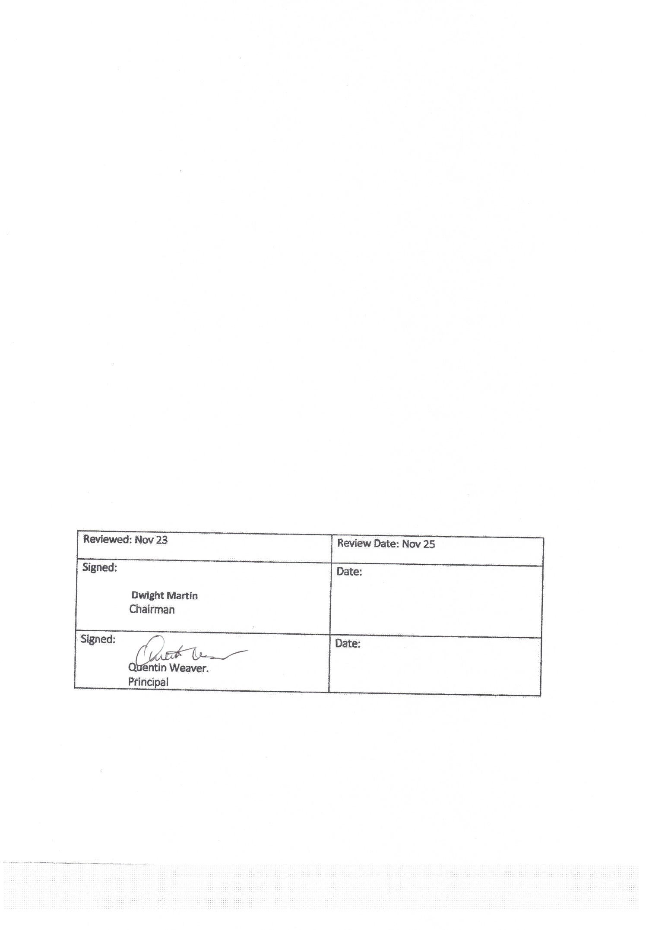
Wellbeing Policy

Introduction

Our Mission Statement reflects our commitment to excellence in educational achievement, wellbeing and personal growth. We ask our students to

- To have a good attitude
- To be part of the group

Our curriculum and the environment we provide promotes the wellbeing of both our students and our staff. The Loughmiller way, which we use) has shown that a child responds quicker to education when the underlying issues of rejection, fear or failure are addressed and a path towards successful outcomes is achieved. The child learns to believe in themselves once again and that they have the ability to strive in life and in education. Our whole curriculum is based on wellbeing.

Wellbeing is multidimensional in nature and includes:

- Effective pedagogical practice which enhances students’ educational achievement and personal development.
- A system to support such achievement and development.
- Parental guidance and support to allow our students to make positive and responsible decisions relating to their health and wellbeing and the wellbeing of others.
- Opportunities for staff members to build capacity and work in a respectful, supportive environment.

Students learn more effectively and have better academic outcomes if they are happy in their work, believe in themselves and feel acknowledged and supported; an environment which we nurture in our school.

Context
The Department of Education and Skills has set out the Wellbeing Policy Statement and Framework for Practice which we have referenced to support and promote the wellbeing of students in our care and informs this Policy.

Wellbeing is present when a person realises their potential, is resilient in dealing with the normal stresses of their life, takes care of their physical wellbeing and has a sense of purpose, connection and belonging to a wider community. It is a fluid way of being and needs nurturing throughout life (World Health Organisation).

Student wellbeing is present when students realise their abilities, take care of their physical wellbeing, can cope with the normal stresses of life and have a sense of purpose and belonging to a wider community (Junior Cycle Guidelines).

Research has shown that there are factors which have a positive influence on wellbeing and factors which have a negative influence on the promotion of wellbeing in a school. The positive influences are referred to as protective factors for wellbeing while the negatives are referred to as risk factors.

Wellbeing protective factors include:
- Positive relationships with peers and teachers- including positive teacher classroom management strategies and a sharing of positive behaviour management practices with parents.
- A sense of belonging, security, and connectedness to the school through a positive school climate and participation in school and community activities.
- Opportunities for social and emotional learning including the development of attention and planning, self-awareness, self-management, relationship and responsible decision-making skills.
- Opportunity for the development of knowledge and skills providing a sense of mastery and self-efficacy.
- Fostering expectations of high achievement and providing opportunities for success.
- Wellbeing of school personnel including teaching, caretaking and administrative staff.
- Protocols and support systems that proactively support students and their families should difficulties arise.
- Opportunities to develop the necessary skills to cope with using online technology in a safe and appropriate way.
- Opportunities to develop skills to manage stress that may be linked to school work.

Wellbeing risk factors include:
- Disengagement, absenteeism, isolation, and alienation.
- Aggression, bullying and relationship difficulties
- Low achievement/learning difficulties/special educational needs including social, emotional, and behavioural needs.
- Cultural differences
- School transitions
- Poor connection between family and school
- Harsh and inconsistent discipline
- Lack of opportunity to develop social and emotional learning, including problem solving and coping skills.

Specific components which promote school based protective factors and reduce school -based risk factors in the promotion of wellbeing include the following:

- The nature of the school environment and connectedness with the environment are key determinants of success in terms of wellbeing promotion. We aim to develop wellbeing by fostering warm relationships, encouraging participation, developing student and teacher autonomy, and ensuring clarity about boundaries, rules and positive expectations.
- Wellbeing promotion carries through to all aspects of teaching and learning. The daily experience of teaching and learning contributes greatly to wellbeing.
- We aim to ensure that teaching and learning is inclusive, engaging, differentiated, fostering expectations of high achievement, and providing opportunities for success. The delivery of our SPHE programmes provides an opportunity for all students in our school to engage in the promotion of wellbeing.
- In line with best practice the Continuum of Support offers a framework within which we address all educational needs including wellbeing needs. This connects our Guidance Plan with our SPHE Programme and our Wellbeing Policy.
- The relationship that teachers develop with students is a key influence on wellbeing development. Access to any member of staff who can guide and support a student at a vulnerable time is identified as a protective factor. Our Wellbeing Team supports our wellbeing policy and practice.
- Support for the wellbeing of staff is also an essential element and important in sustaining staff engagement, enthusiasm, and ability to model resilience. It builds staff capacity to cope with challenges and adapt to change and creates conditions to support and motivate staff to be effective in their roles.

Our aim is to strengthen school-based protective factors and minimise school-based risk factors. We operate a whole school approach to wellbeing, and this involves the school community engaging in a collaborative process of change to improve specific areas of school life that impact on wellbeing.

The role of staff and the importance of building professional capacity to engage in a reflective process in order to implement and sustain our wellbeing policy and strategies, cannot be overemphasized.
We have enhanced our student voice by providing opportunities for our students to provide feedback on school policy and procedure.

Wellbeing Provision:
While every teacher can support student wellbeing, it is further enhanced when important aspects of wellbeing are the subject of learning and teaching in specific curriculum areas and are allocated specific time.

The education we provide is key to equipping students with the knowledge, skills and competencies to deal with the challenges that may impact on their wellbeing. Based on our knowledge of the challenges our students are facing we have identified the following needs which will be the focus of our wellbeing programme:

- The building of resilience which will assist students in dealing with anxiety and stress.
- The development of a strong moral compass with the intended outcome of developing a culture where students have the strength to do the right thing in challenging situations.
- The importance of physical activity to aid mental wellbeing.
- Effective pedagogical practice to ensure that students have a positive sense of themselves as learners and a strong sense of their capacity to improve and achieve.

Indicators:

The following Indicators have been identified as central to wellbeing (National Council for Curriculum and Assessment) and inform our programme:

- Active
- Responsible
- Connected
- Resilient
- Respected
- Aware

The school Self-Evaluation process will be used to promote a review and development of our Wellbeing Programme. However, even with our best efforts, the wellbeing of individuals can be compromised by the wider social, economic and cultural landscape. Wellbeing is the responsibility of students, parents, school and the wider community; and so we will provide opportunities for feedback as we review our practice and procedures on a regular basis and as required.

Support
In the event of a student being identified as needing support and where their wellbeing is deemed to be compromised the wellbeing team will refer to the students GP. We will contact the parents/guardians of the child and meet to develop a wellbeing plan.

